Case 5-Asia-China-Hongshan-Liaoning-Cicada-First Instar Nymph-Amulet-Jade-4700-2920 BCE

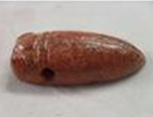

This example of a Cicada First Instar Nymph Amulet symbolizes the life cycle of the cicada which begins as a nymph that having hatched from an egg on a tree branch, falls to the earth as a stubby First Instar, burrows in the ground, and attaches to rootlets where it is sustained by the root's nourishment for as many as seventeen years when it is mysteriously called into the light of day, climbs the trunk of the tree, its skin splits open, and its wings unfurl as a mature cicada.